What is Hayat Life Care?
Hayat Life Care is a one-stop lifestyle destination, set to become the largest diagnostic and doctor consultation center in Chattogram. It is designed to offer a combination of healthcare, daily essentials, wellness, and leisure facilities — all under one roof.
Basically, a holistic approach to solve boring waiting time for doctors’ visit into quality family time by providing all essential services under one roof.

Is it registered company in Joint Stock?

Yes. It’s a registered company.

Who is the Chairman and Managing Directors?

Chairman: Capt. Md Showkat Hossain Chowdhury / Vice Chairman: Dr. Abu Naser

Managing director: Dr. Md Azizul Hoque /DMD: Md Abu Bakkar Siddiki,

Marketing Adviser and One of the Founding Director: Capt. Atique UA Khan

Founding Director: Mr Md Sayed Noor, Ex- SAVP NCC Bank, Founder director Lohagara somiti. /Founding Director: Md Iqbal Hossain

Where is it located?
Corner Plot of O.R. Nizam Road & Badsha Mia Road (War Cemetery Road), Chattogram. West of Chattogram Medical College and Hospital (CMCH). Opposite to CSCR. (Ex: Equity office / Dentist: Sikder)

What is the land area and structure?
  - Land Area: 55 Katha (Govt. acquisition some portion awaiting final confirmation.)
  - The structure will be around 14-18 for above. In Picture upto 8 is the above 11 business. Above level 8 there will be especially a hospital.
  - The picture is a demo as we are awaiting to have plan from CDA.
  - Parking: 150+ paid car parking spaces

Are you owner of full building?

Yes, Hayat Life Care will be the complete sole owner of the land and building and all business wings. The structure and its all business will be managed by the single management “Hayat Life Care”

Why only 8 storied buildings in 55 Katha?

Actually, the building will be 14-18 floors. Above level 8th, a specialized hospital. As of now our targets are Cancer, Heart, Kidney, Gyne & Obs.

Floor-wise Usage:
  - Basement (3 levels): 150+ paid car parking
  - Level 1: Super shop, pharmacy, optical shop, coffee shop, and ATM booth
  - Level 2: Restaurant, and amusement park
  - Levels 3–8: Diagnostic and consultation center (It may include a Cancer and Infertility Unit with advanced machines such as PET scan, which are not currently available in Chattogram).
  - Above 8: Specialized hospital, Cancer, Heart, Kidney, Gyne & Obs

What is the complete plan?
Key Information:
- The plan to develop Super shop, ATM Booth, Children Amusement indoor Park, Coffee Shop, Juice Bar, Restaurant, Doctor’s consultation and Diagnostic Center as well as various non-hospitalized medical services within upto Level 8.
- The spaces are to be designed and developed to fulfil the requirements of Hayat Life Care Ltd.

Future Healthcare Expansion

A specialized hospital is planned above level 8. It will be built at a single shot.

Establishment will be subject to approval from all relevant authorities and regulatory bodies

Expected Handover Date?
  - Revenue generation expected from December 2027 (+ 6months)
  - Full-scale operations by 2028 Dec (+ 9-months) upto level 8.
  - Hospital operations by 2030 Jun (+ 9-months)

Within 2 years is it not very optimistic?

We have 11 business wings; among them we can start 10 business wings within 8 months of the start of construction. Please see the picture of Well Food, GEC, how they operate business under construction building by Equity.

Why Invest in Hayat Life Care?
  - The largest diagnostic and consultation center in Chattogram with strong business projections.
  - Converting waiting time for doctors’ visit to quality lifetime with family and or friends.
  - Unique idea in all over Bangladesh that Mixture of Healthcare and daily essentials with quality time building projects.
  - Combines healthcare with a lifestyle experience — restaurants, supermarkets, amusement parks, cafés, ATM booths, car parking etc.
  - Offers car parking (150+), which is also unparallel with surrounding health care facilities
  - Prime location with high visibility and accessibility
  - Total 11 business wings under one roof but Single management. (Parking, ATM, Pharmacy, Optical Shop, Super shop, Coffee shop, Juice Bar, Restaurant, Children Amusement Park, Doctors’ chamber, diagnostic center)

Will There Be a hospital?

Yes. But that is future expansion which will be established at earliest.

Pediatric and Family Care?

Yes, family-focused healthcare is a key priority of Hayat Life Care.

Who will operate / run the Company?

The company will be run by high skill professional, named “operational team but all are employee” like Unilever / Glasco / Standard Chartered // We even don’t know who the owner of PEPSI/ HSBC is etc.// From the board of director there will be a “Management Committee” who will look after the operation team very closely. The committee might be 13-17 people. // FYI, traditionally, like other nearby hospitals, have more than 100 directors but only 5-10 directors operate the organization.

Who Is Leading Hayat Life Care?

Capt. Md Showkat Hossain Chowdhury,
Master Mariner and Chairman of Marinus Pvt. Ltd & Hayat Holdings Pvt. Ltd., with extensive experience in marine and construction industries, both nationally and internationally.

Dr. Mohammad Azizul Haque
Associate Professor at Chattogram Medical College & Hospital. Founder Director of Ekushey Hospital, Park View Hospital, Treatment Hospital, and Delta Hospital.

How will profit be distributed?

An amount to be paid monthly to all shareholders according to his /her share proportionately upon full swing operation commenced and company in profit. Expecting to distribute from complete operation of the project which is tentatively Dec 2028

What are the profit expectations?

Health care is the first position in sustainable income in Bangladesh. Considering this unique project, we are confident to be profitable since inception In Sha Allah.

According to our financial survey the expected profit might be 10% from the 3rd year of operation, which might increase with the maturity of the business further. However, no one can guarantee the business profit / loss or future, but Company has a robust, intellectual and surveyed strategy for which we all might hope for better return In Sha Allah. We have plans to declare the profit from the first year In Sha Allah.

How do you determine this 10% profit?

Our survey data from the similar institute. However, we are expecting more as our project is unique in city as well as all over the country and various demanding business wings (Like Car Parking, Restaurant, Children amusement park, etc.) under one roof.

How will ensure transparency and accountability?

Like other companies, it will be audited by the govt approved 3rd party audit farm. Like Metropolitan / Park View / CSCR are running.

Do I get registration of land / building? Or will there be any registration with my name?

For a company, all assets are always registered with the company name. Similarly, Hayat Life Care Ltd will be the registered owner of complete area/ space including land. All shareholders, including founder directors, are the combinedly owners of the spaces including land proportionately.

- Is there any buyback policy?
Yes. After the 3 years of operation at a 5% higher price than the share value.

- If my spouse / relative is doctor, will they get any benefit?
Yes, during allocation of chamber or any job in the organization, if qualification is equal
or a bit less, management will prioritize the shareholder recommendation. However,
Quality has to be ensured and subject to availability.

How to Book a Space?

Visit office and finalize the slot you like to book which is suitable for your own finance.

Share price and Benefit
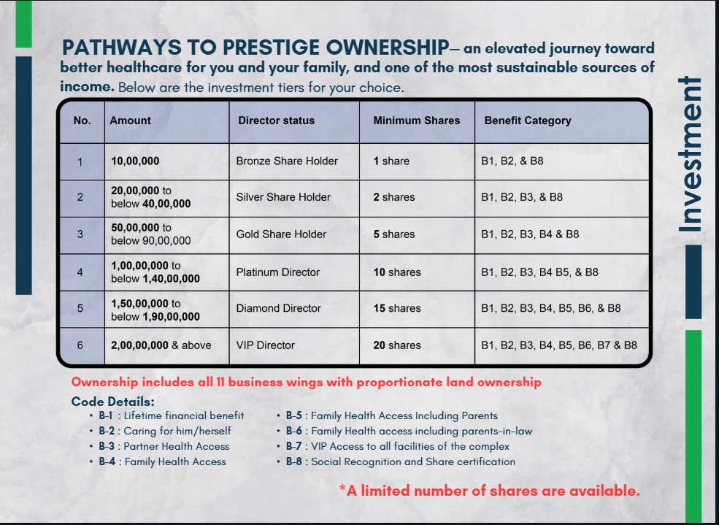

Do I need to pay additional for Hospital

No. You do not need to pay later on for hospital establishment. Your payment is fixed as per the current slot, 10 lacs/ per share.

From where will the money come for hospital establishment?

1st Phase share: 2500, Per Share value: 10 lacs = 250 crores

Now we are at first page.

2nd phase share: 500, Per Share value: 15 lacs = 75 crores

Time of construction start.

3rd phase share: 1000, Per Share value: 20 lacs = 200 crores.

Time ground floor and 1st floor business running.

NO BANK LOAN WILL BE TAKEN. *** If needed, we can sale shares from the reserve.

What is the maximum share of the company:

Less share means more benefit. So, we like to cover with minimum share. our plan to take 4000 shares but we will n’t cross 4950share at any case. If we do, we will take full consent of shareholders in AGM.

For future business expansion, company usually do like this.

When will hospital work start?

Construction will be completed in a single shot. But opening will depend of permission from all the authorities and necessary arrangement.

Can I sale the shares / directorship?
A shareholder has the right to sell their shares; however, they must notify the management of Hayat Life Care in advance and obtain written approval before proceeding with the sale. Additionally, a royalty fee equivalent to 10% of the profit shall be paid to Hayat Life Care before completion of the transaction. So, owners will get original amount and 90% of profit of sale price.

Required Documents:

National ID including Nominee, TIN if any.
  - Present, permanent address & Contact number

Mode of Payment:

Option-1:

1a. On deed date: Down payment 50%.

1b. 1st installment: 25% within 30 days from deed date

1c. 2nd installment: 25% within 60-90 days from deed date//

Option-2: (By the directors only)

2a. Deed date: Down payment: 35%

2b. 1st installment: 30% within 30 days from deed date

2c. 1st installment: 35% within 60-90 days from deed date

What Documents Will We Provide?
  - Agreement on a BDT 300 non-judicial stamp paper.
  - Money is to be deposited into a company account. Money deposit slip.
  - Company formatted official money receipt.
  - Share certificates (after completion of all share sales and commence of operation. As need to mention, how many shares you own. example “Out of 4000 share you are the owner of 10 shares”)
  - Letter of allotment (RJSC) after enrolment as PLC in RJSC.

Is mean, the size will reduce from 55 katha?

Yes, we are waiting for confirmation from CDA and LA section. The acquisition, so far we know unofficially, still Hayat Life Care will be the biggest hospital building within the main city (except Evercare and Imperial).

Our Unique Idea?
- Completely separate diagnostic floor for the female patient.
- Convert waiting time for doctors into quality family time.
- AI Based smart technology which is Paperless healthcare system.
- Blanding of health care and daily essentials.
- Relax in your stay as your car is in secured parking area. (Largest parking space)
- Collaboration with international hospitals where Chattertonian is frequently visiting for post and follow-up treatment. Like (Bumgungrad Hospital / MedPark / Samitivej / Apollo / CMC Vellore / Fortis / Tata Memorial / Narayana Health / Mouth Elizabeth Hospital / Raffles Hospital / Gleneagles Hospital)
- Achieve international accreditation, acceptance and international recognition.
- First PetScan in Chattogram. (Cancer detection center)
- First specialized hospital in Chattogram (Cancer, Heart, Kidney, Gyne & Obs)
- Total business wings under one roof but Single management. (Parking, ATM, Pharmacy, Optical Shop, Super shop, Coffee shop, Juice Bar, Restaurant, Children Amusement Park, Doctors’ chamber, diagnostic center)

